**SavorEat - STM32F767ZI CLI version user’s manual**

After loading the CLI version to the STM board, connect your computer to it via terminal with the following configuration:

Serial port, speed 115200 bits/sec (according to the assigned COM port of your computer.

Reset the board by pressing the black push button and the following menu will appear:

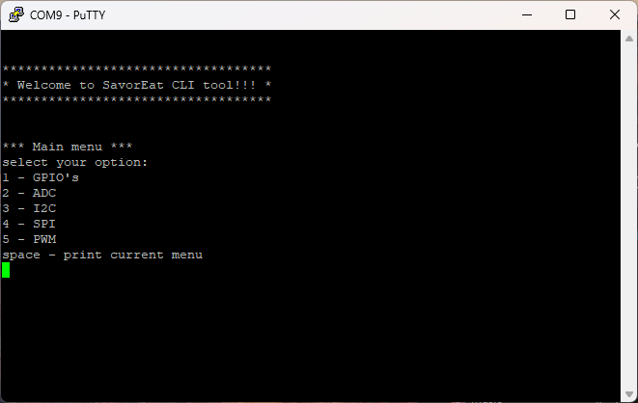

This is the main menu:

Pressing 1 will move you to GPIO’s menu.

Pressing 2 will move you to ADC menu.

Pressing 3 will move you to I2C menu.

Pressing 4 will move you to SPI menu.

Pressing 5 will move you to PWM menu.

Pressing space will print the current menu again.

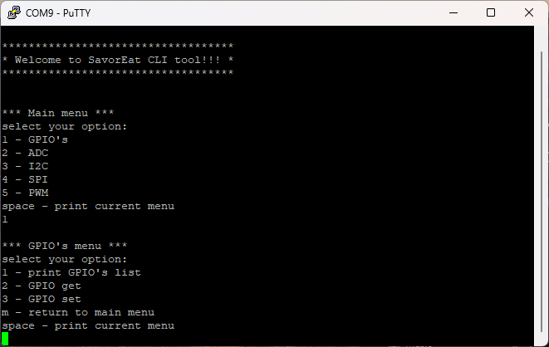

GPIO’s Menu:

Pressing one will print the entire configured GPIO’s of the system:

First column GPIO’s ID.

Second column GPIO’s description.

Third column GPIO's port and pin.

Forth column GPIO's input or output.

Pressing 2 will perform GPIO’s Get command:

You will be requested to enter the GPIO’s ID (according to the list described in GPIO’s list).

Pressing 3 will perform GPIO’s Set command (only active on Outputs ports):

You will be requested to enter the GPIO’s ID (according to the list described in GPIO’s list) then you will be requested to enter the value (0 or 1).

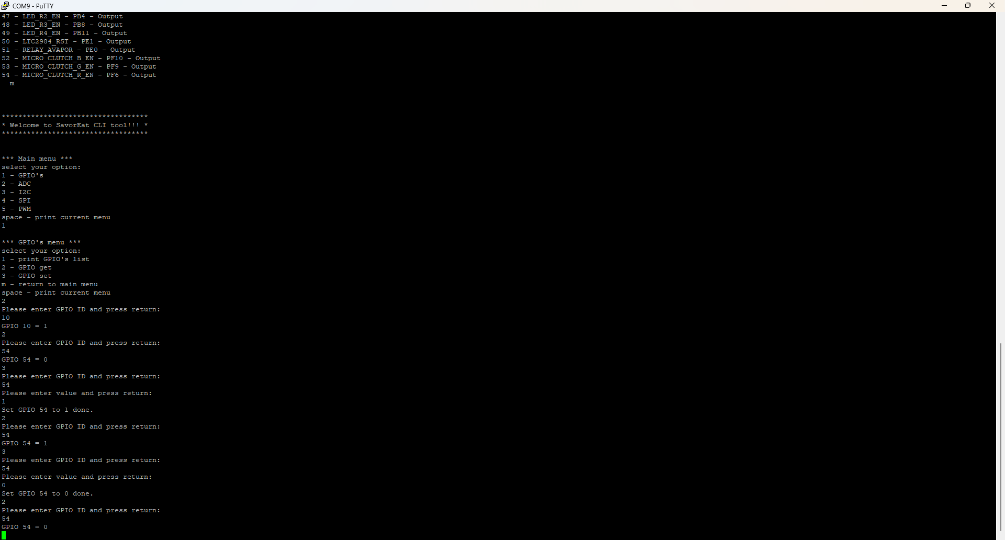

Pressing space will print the current menu.

Pressing m will bring you back to main menu.

ADC menu:

Pressing 1 – 5 will sample the ADC channel according to the menu and print the raw sampled menu.

Pressing space will print current menu.

Pressing m will bring you back to the main menu.

I2C menu:

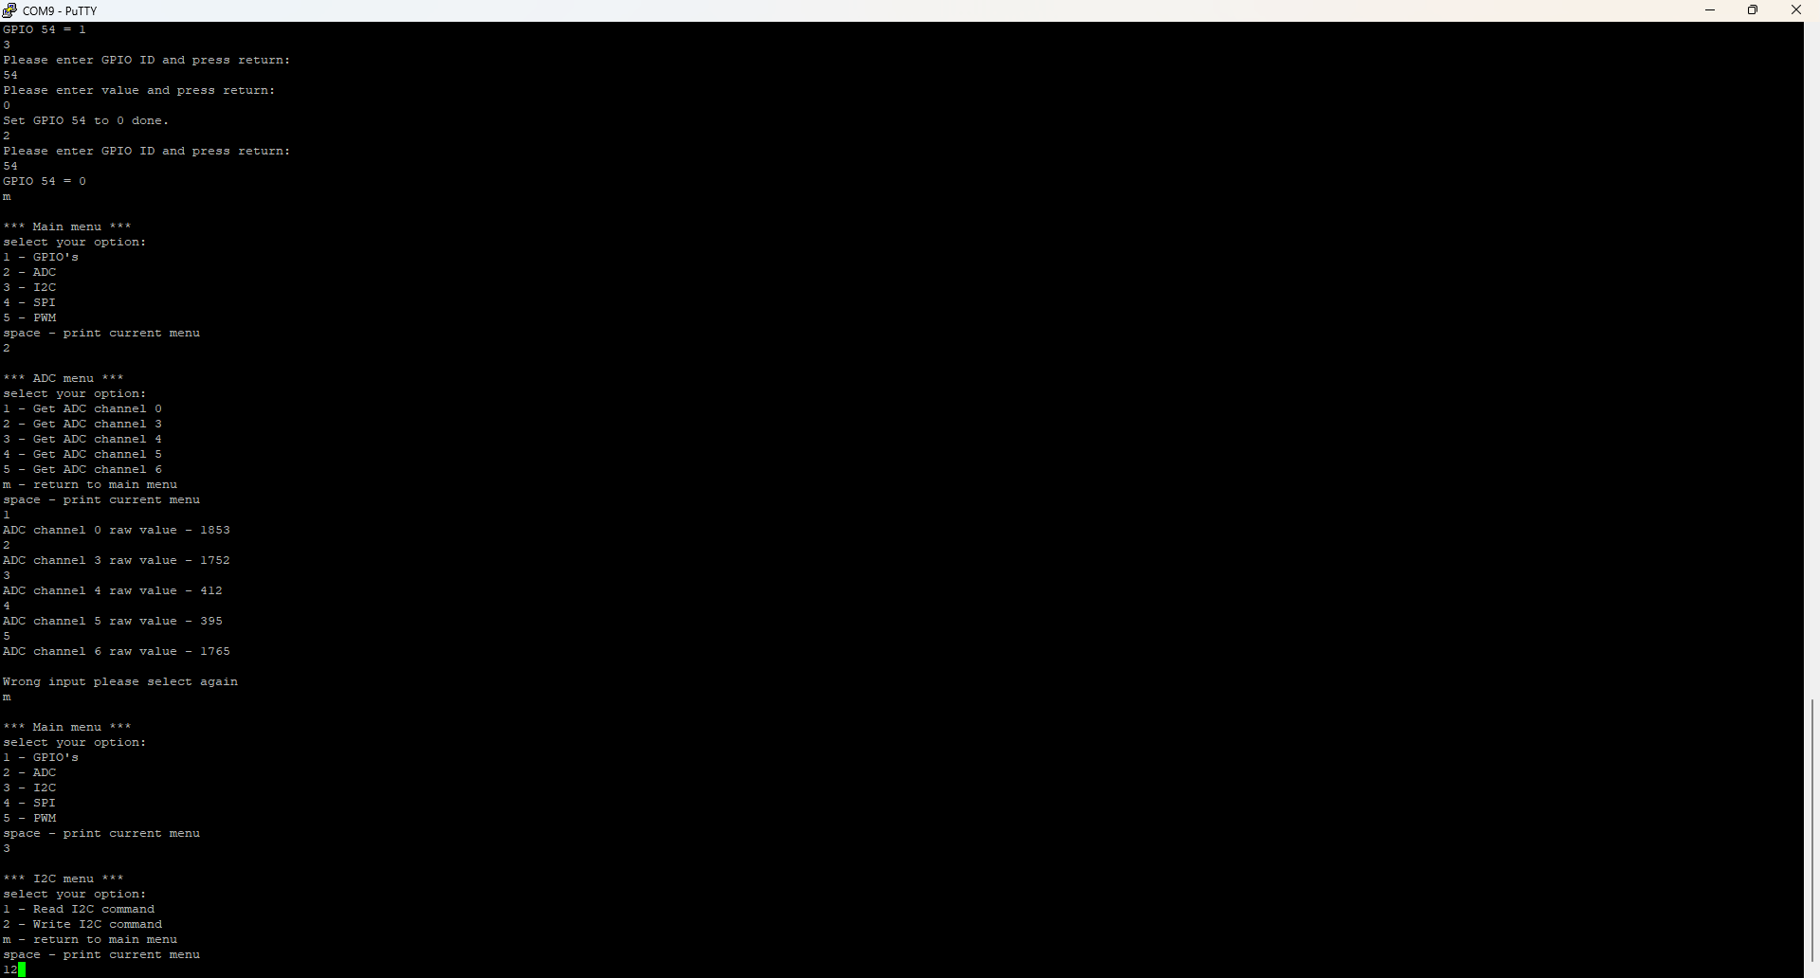

I2C4 Bus, Slave address 0x80 , reg – 0x0, data – 0x10

Pressing 1 will send a Read I2C request.

Pressing 2 will send a Write I2C request.

Pressing space will print current menu.

Pressing m will bring you back to the main menu.

SPI menu:

Pressing 1 will Receive SPI command.

Pressing 2 will Transmit SPI command.

Pressing space will print current menu.

Pressing m will bring you back to the main menu.

PWM menu:

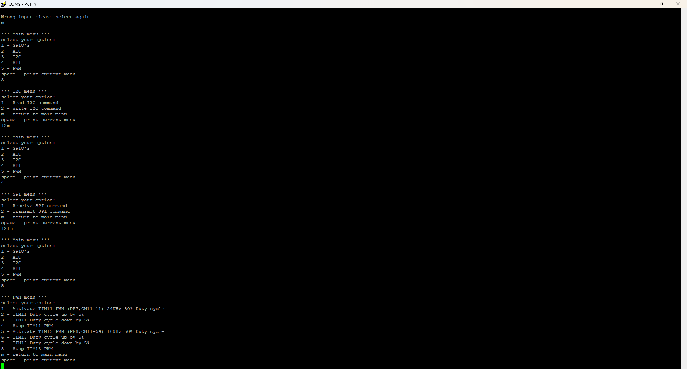

Pressing 1 will activate TIM11 PWM (PF7, CN11-11) 24KHz 50% Duty cycle.

Pressing 2 will raise TIM11 Duty cycle up by 5% (until 100%).

Pressing 3 will reduce TIM11 Duty cycle down by 5% (until 0%).

Pressing 4 will Stop TIM11 PWM.

Pressing 5 will activate TIM13 PWM (PF8, CN11-54) 100Hz 50% Duty cycle.

Pressing 6 will raise TIM13 Duty cycle up by 5% (until 100%).

Pressing 7 will reduce TIM13 Duty cycle down by 5% (until 0%).

Pressing 8 will Stop TIM13 PWM.

Pressing space will print current menu.

Pressing m will bring you back to the main menu.